The mobile phone charging plug pictured below was discovered as part of the routine Portable Appliance Testing, (PAT), programme.

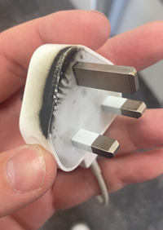

The discolouration of the casing indicates that the plug has overheated and that there has possibly been a fire however the socket that this was in showed no signs of damage. The fact that there was no indication of damage to the socket leads us to believe that the plug was known to be faulty yet was still being used which is a serious safety issue.

It is important that everyone in the Department visually inspects any electrical item before it is used and if there is any doubt about its condition advice should be sought before using it. This is explained in the following University Safety Office document [Electrical Safety: 12 Rules](https://www.safety.admin.cam.ac.uk/system/files/hsd101p.pdf)

Other guidance on the use of plug adaptors and extension leads can be found in the [Guidance for the use of Electrical Adaptors and Extensions](https://www.safety.admin.cam.ac.uk/system/files/hsd174p.pdf)

If you see anything that you believe to be dangerous please report it to your Supervisor, Line Manager, Divisional Lab Manger or Technician.

Kind Regards,

CUED Safety Office